**CHAPTER 3**

**RESEARCH DESIGN AND METHODOLOGY**

In this chapter, the experimental design and the methodology employed are presented. A quantitative experimental research method is used in this study to show the effectiveness of the seashell ash as the replacement of the cement. Using Oyster Shell, Cockle Shell, and Mussel Shell as the raw materials, the researcher aims to produce fly ash. During the experiment, the variables will be meticulously controlled such as the temperature and the volume of the fly ash for the production of the CHB.

**3.1 Research Materials and Equipment**

Shells from mussels, cockles, and oysters are among the materials used in the study. In the Province of Misamis Occidental, Philippines, where some seashells are embedded in sea rocks or sticking to boats or barrels, the seashells used in the study are waste that has been dumped by the beach or that has been thrown by people after eating its meat and even on business owners. The following parts included the study's equipment description and the research materials.

**3.1.1 Oyster Shell (*Crassostrea Iredalei)*, Cockle Shell ( *Cerastoderma edule*) and *Mytilus Edulis* (Mussel Shell)**

The Province of Misamis Occidental will be the source of the seashells used in the experiment. The oyster shells were supposed to be dumped as waste by the company, but the owner retained them while she awaited their eventual purpose. The business owner has a collection of seashells and is willing to give them to researchers as research materials. In the Province of Misamis Occidental, you can see and gather the two kinds of seashells mentioned above along the coastline, especially during low tide.

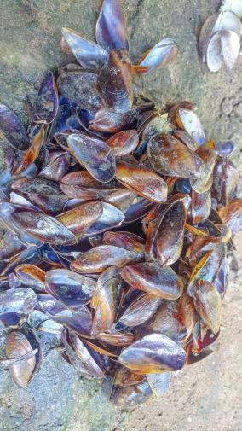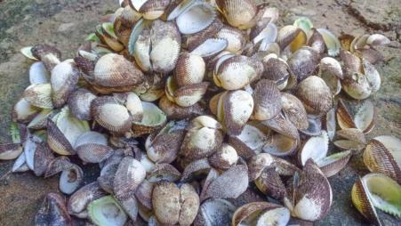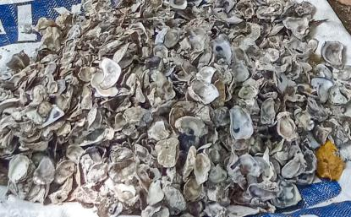

*Figure 3.1.1 Oyster Shells, Cockle Shells, and Mussel Shells*

**3.1.2 ASTM Standards**

Several ASTM standards will be used as references for material requirements, test procedures for assessing concrete qualities, and other procedures that help arrive at the study's conclusions. The ASTM standards that will be used in the study are listed below:

**Table 3.1 List of ASTM Standards**

|  |  |
| --- | --- |
| **Materials, Properties and Test Methods** | **Standard** |
| Cement | ASTM C 150 |
| Fine Aggregates | ASTM C 136 |
| Compressive Strength | ASTM C 387 |
| Slump | ASTM C 143 |
| Curing | ASTM C 31 |

**3.1.3 Cement**

The Ordinary Portland Cement Type 1 will be the cement used in the mixing procedure, and will be purchased at a hardware store in Lopez Jaena depending upon the desired mixture composition. The composition will be changed appropriately to produce the necessary number of specimens.

**3.1.4 Fine and Coarse Aggregates**

ASTM C136 is used to determine the grading of materials that are to be used as aggregates. Fine aggregates with a maximum diameter size of 2mm will be utilized in this study for CHB mixture. Coarse aggregates will also be used in CHB mixing with a maximum size of 20mm in diameter. These aggregates will be collected from aggregate manufacturer to ensure good quality. The composition of these materials will also be adjusted in accordance to the needed number of specimens for test methods.

**3.1.5 Water**

Water will also be added to the CHB mixture, and it is anticipated that its proportions will change. To ensure consistency in the mixing procedure, the material will be readily available and precisely metered.

**3.1.6 Molder**

The specimen molders that will use in the study are the rectangular molder with a height of 150 mm with the length of 300 mm and width of 200 mm for compressive strength. For compressive strength tests, the researcher will make 3 specimens in each sample variety made up of 4 ratios, including plain concrete mixture.

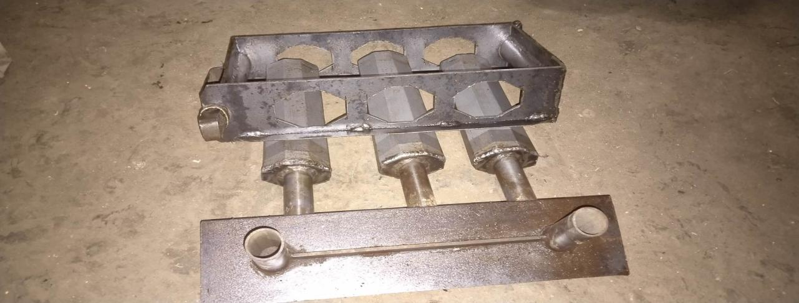

*Figure 3.1.6 3.25” x 7.5” x 14.75” Molder*

**3.1.7 Pots**

The uncalcined samples will be kept in pots since they are heat-resistant and won't melt or shatter at high temperatures.

**3.1.8 Crusher**

Crushers will be used to reduce the size of a solid raw material mixture (such as rock ore) so that pieces with different compositions can be distinguished. In this study, the seashells are crushed manually to ease calcination process.

**3.1.9 Calcination Machine**

Calcination is the thermal treatment of a solid chemical compound (such as mixed carbonate ores) in which the compound is heated to a high temperature without melting while being supplied with a limited amount of ambient oxygen (i.e., the gaseous O2 fraction of air), typically in order to remove impurities or volatile substances and/or cause thermal decomposition.

Calcination Machine that will be used is located at Ceramic Training Center - MSU-IIT, Iligan City.

**3.1.10 Ball Mill Equipment**

In production lines for powders like cement, silicates, refractory material, fertilizer, glass ceramics, etc. as well as for ore treatment of ferrous and non-ferrous metals, the ball mill is a crucial piece of machinery for grinding crushed materials.

**3.1.11 Sieving Equipment**

The sieving apparatus will be utilized for sieving analysis and aggregate gradation. The apparatus' purpose was to aid in particle mobility through a stack of sieves, enabling precise particle separation. As the particles separate, they are held on different sieves based on their size, giving information on the sample's typical particle size.

The Ceramic Training Center at MSU-IIT in Iligan City, where the sieving procedure will also be carried out, will provide the equipment for usage. The method will make use of Sieve #200.

**3.1.12 Eagon 2 Flux Machine**

A fully automatic fusing machine called Eagon 2 is used to prepare fused bead samples for XRF analysis.

**3.1.13 Oven**

Oven is used for drying the samples before testing.

**3.1.14 XRF (X-ray Flourescence)**

X-ray fluorescence, often known as XRF, is a process whereby electrons are moved out of their atomic orbital positions and release a burst of energy unique to a particular element. The XRF instrument's detector subsequently detects this energy release and classifies it according to the elements it belongs to.

It is where the samples are examined.

**3.1.15 Universal Testing Machine (UTM)**

The Universal Testing Machine (UTM) is used to test the compressive strength to a test specimen in order to determine its mechanical characteristics.

**3.2 Sample Preparation**

The raw materials used in this study will undergo various processes before the CHB mixture and preparation of specimens. Below are the procedures of sample preparation including the collection of raw materials, cleaning and drying, burning and crushing, sieving and calcination process, and chemical analysis of the seashell’s fly ash.

**3.2.1 Collection of Oyster Shell, Mussel Shell and Cockle Shell**

The materials that will be utilized in the study are the oyster shells, mussel shell and cockle shell. The said seashells will be collected from the Province of Misamis Occidental contained in storage bags (e.g., sack). The researchers will gather and prepare a sufficient number of the material in order to obtain the desired number of specimens.

**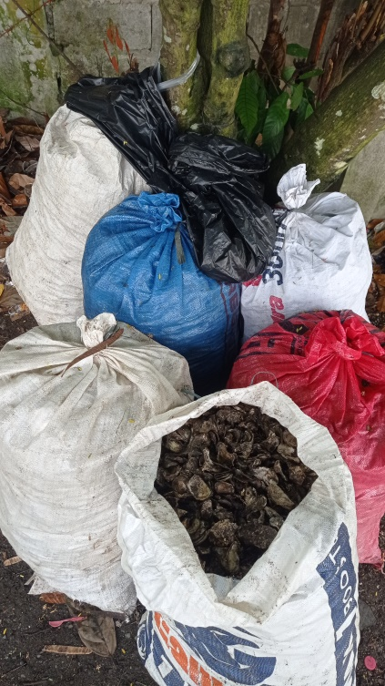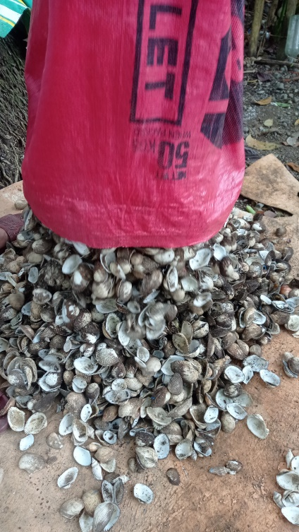**

*Figure 3.2.1 Collection of Oyster Shell, Mussel Shell and Cockle Shell*

**3.2.2 Cleaning & Drying Processes**

The collection of raw materials will be followed by the cleaning process which will take place in the residence of Sumile Family located in Danlugan, Lopez Jaena Misamis Occidental. The seashells will be washed using the water pump or what we called “poso” in our vernacular language while the researchers wash and brush them individually for several times to remove the dirt, mud and other unwanted substances on the shells.

After the cleaning process, the researchers will begin the drying process of the seashells. The former will be laid on a flattened sack on an even surface under the sun for a minimum of 5 hours until they dry. This is done in order to optimize the energy potential of the materials by minimizing moisture content and enhancing combustion performance.

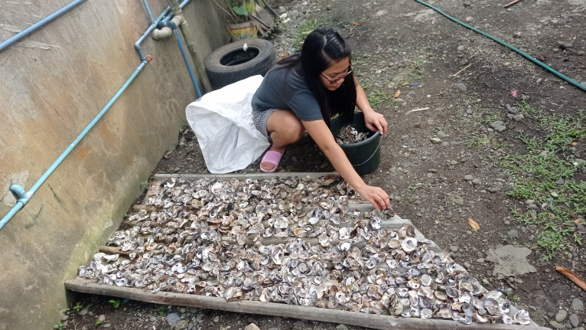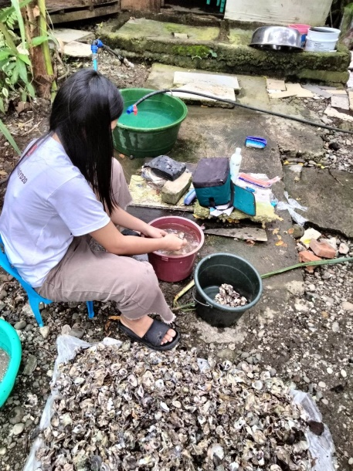

*Figure 3.2.2 Cleaning & Drying of Seashells*

**3.2.3 Crushing of Dried Seashells**

Fore mostly, for ease in calcination process, the researchers will manually crush the dried seashells into a smaller scale of their original shapes and sizes before it undergo for calcination.

**3.2.4 Calcination Chemical Process**

The calcination chemical process will be conducted in the laboratory of MSU-IIT where the calcination equipment is available. The already crushed seashells will be heated at a maximum temperature of 800°C for 6 hours (Park, et. al., 2007). After calcined, materials will be set and ready for further processes.

**Table 3.2 Weight of Oyster, Mussel and Cockle Shell to Produce OSFA, MSFA, and CSFA**

|  |  |  |  |  |  |  |
| --- | --- | --- | --- | --- | --- | --- |
|  | Material | | | | | |
| OS | OSFA | MS | MSFA | CS | CSFA |
| Weight (kg) | 110 |  | 80 |  | 100 |  |

Above is the table presenting the weight of the three seashells needed in producing the desired weight of the seashell’s Fly ash.

**3.2.5 Ball Milling and Sieving Processes**

Ball Milling and sieving processes will also take place in the laboratory of Ceramic Training Center, MSU-IIT, Iligan City where the equipment needed for both processes are available. The calcinated seashells will undergo sieving process using sieve #200 for a finer particle. The materials will then be subjected for chemical analysis and CHB mixture.

**3.2.6 Chemical Analysis of OSFA, MSFA and CSFA**

In analyzing the chemical components of OSFA, MSFA and CSFA, X-ray fluorescence, often known as XRF will be used. It is an x-ray device used for routinely analyzing fluids, sediments, minerals, and rocks chemically in a reasonably non-destructive manner. The equipment is available in Republic Cement Mindanao, Inc. where chemical analysis will be conducted inside their laboratory.

**3.3 Preparation of CHB Mixture**

The test and analysis in this study followed the M15 grade of CHB. It is a grade of CHB with a mixture ratio of 1:7 that are made of cement and fine aggregates, respectively while keeping the water-cement ratio of 0.5. Grade M15 CHB mix would achieve a compressive strength of 500 psi after curing.

**3.3. Preparation of Mixture for CHB Samples**

**Table 3.3 Mix Proportion Details**

|  |  |  |  |  |
| --- | --- | --- | --- | --- |
| **Mix** | **Designation** | **Percentage Replacement of Cement by Mixture of Oyster Shell and Cockle Shell**  **(by weight)** | | |
| **Total percentage replacement** | **Oyster Shell Fly Ash 25% of total percentage replacement** | **Cockle Shell Fly Ash 25% of total percentage replacement** |
| Mix 1 | M1 | 0 | 0 | 0 |
| Mix 2 | M2 | 5 | 2.5 | 2.5 |
| Mix 3 | M3 | 10 | 5 | 5 |
| Mix 4 | M4 | 15 | 7.5 | 7.5 |

**Table 3.4 Mix Proportion Details**

|  |  |  |  |  |
| --- | --- | --- | --- | --- |
| **Mix** | **Designation** | **Percentage Replacement of Cement by Mixture of Cockle Shell and Mussel Shell**  **(by weight)** | | |
| **Total percentage replacement** | **Cockle Shell Fly Ash 25% of total percentage replacement** | **Mussel Shell Fly Ash 25% of total percentage replacement** |
| Mix 1 | M1 | 0 | 0 | 0 |
| Mix 2 | M2 | 5 | 2.5 | 2.5 |
| Mix 3 | M3 | 10 | 5 | 5 |
| Mix 4 | M4 | 15 | 7.5 | 7.5 |

**Table 3.5 Mix Proportion Details**

|  |  |  |  |  |
| --- | --- | --- | --- | --- |
| **Mix** | **Designation** | **Percentage Replacement of Cement by Mixture of Oyster Shell and Mussel Shell**  **(by weight)** | | |
| **Total percentage replacement** | **Oyster Shell Fly Ash 50% of total percentage replacement** | **Mussel Shell Fly Ash 50% of total percentage replacement** |
| Mix 1 | M1 | 0 | 0 | 0 |
| Mix 2 | M2 | 5 | 2.5 | 2.5 |
| Mix 3 | M3 | 10 | 5 | 5 |
| Mix 4 | M4 | 15 | 7.5 | 7.5 |

**Table 3.6 Mixture of Samples for Compressive Strength**

|  |  |  |  |  |
| --- | --- | --- | --- | --- |
| **Sample** |  | **Weight of composites for 3 replicated specimens**  **($kg$)** | | |
| **Cement** | **COCKLE SHELL** | **Sand** | **Water** |
| **M1** | **0.57** | **0** | **7 ¾** | **¼** |
| **M2** | **0.52** | **0.05** | **7 ¾** | **¼** |
| **M3** | **0.50** | **0.07** | **7 ¾** | **¼** |
| **M4** | **0.49** | **0.08** | **7 ¾** | **¼** |

**Table 3.7 Mixture of Samples for Compressive Strength**

|  |  |  |  |  |
| --- | --- | --- | --- | --- |
| **Sample** |  | **Weight of composites for 3 replicated specimens ($kg$)** | | |
| **Cement** | **MUSSEL SHELL** | **Sand** | **Water** |
| **M1** | **0.57** | **0** | **7 ¾** | **¼** |
| **M2** | **0.52** | **0.05** | **7 ¾** | **¼** |
| **M3** | **0.50** | **0.07** | **7 ¾** | **¼** |
| **M4** | **0.49** | **0.08** | **7 ¾** | **¼** |

**Table 3.8 Mixture of Samples for Compressive Strength**

|  |  |  |  |  |
| --- | --- | --- | --- | --- |
| **Sample** |  | **Weight of composites for 3 replicated specimens**  **($kg$)** | | |
| **Cement** | **OYSTER SHELL** | **Sand** | **Water** |
| **M1** | **0.57** | **0** | **7 ¾** | **¼** |
| **M2** | **0.52** | **0.05** | **7 ¾** | **¼** |
| **M3** | **0.50** | **0.07** | **7 ¾** | **¼** |
| **M4** | **0.49** | **0.08** | **7 ¾** | **¼** |

**Table 3.9 Mixture of Samples for Compressive Strength**

|  |  |  |  |  |  |
| --- | --- | --- | --- | --- | --- |
| **Sample** | **Cement** | **Weight of composites for 3 replicated specimens**  **($kg$)** | | | |
| **COCKLE SHELL** | **MUSSEL SHELL** | **Sand** | **Water** |
| **M1** | **0.57** | **0** | **0** | **7 ¾** | **¼** |
| **M2** | **0.52** | **0.025** | **0.025** | **7 ¾** | **¼** |
| **M3** | **0.50** | **0.035** | **0.035** | **7 ¾** | **¼** |
| **M4** | **0.49** | **0.04** | **0.04** | **7 ¾** | **¼** |

**Table 3.10 Mixture of Samples for Compressive Strength**

|  |  |  |  |  |  |
| --- | --- | --- | --- | --- | --- |
| **Sample** |  | **Weight of composites for 3 replicated specimens**  **($kg$)** | | | |
| **Cement** | **OYSTER SHELL** | **COCKLE SHELL** | **Sand** | **Water** |
| **M1** | **0.57** | **0** | **0** | **7 ¾** | **¼** |
| **M2** | **0.52** | **0.025** | **0.025** | **7 ¾** | **¼** |
| **M3** | **0.50** | **0.035** | **0.035** | **7 ¾** | **¼** |
| **M4** | **0.49** | **0.04** | **0.04** | **7 ¾** | **¼** |

**Table 3.11 Mixture of Samples for Compressive Strength**

|  |  |  |  |  |  |
| --- | --- | --- | --- | --- | --- |
| **Sample** |  | **Weight of composites for 3 replicated specimens**  **($kg$)** | | | |
| **Cement** | **OYSTER SHELL** | **MUSSEL SHELL** | **Sand** | **Water** |
| **M1** | **0.57** | **0** | **0** | **7 ¾** | **¼** |
| **M2** | **0.52** | **0.025** | **0.025** | **7 ¾** | **¼** |
| **M3** | **0.50** | **0.035** | **0.035** | **7 ¾** | **¼** |
| **M4** | **0.49** | **0.04** | **0.04** | **7 ¾** | **¼** |

**3.4 Mixing Process**

**3.4.1 Plain CHB Mixture**

The researchers will produce replicated specimens for the control group sample of CHB comprising standard CHB mixture of cement, coarse and fine aggregates, and water made with 0% Seashell’s Fly Ash cement replacement. There will be 54 produced rectangular specimens in which will be used in the curing process and compressive strength testing. Also, there are 4 sets of specimens that will stand as the standard requirement for plain CHB, in which the results of utilized green concrete with seashell’s fly ash partial cement replacement are compared to.

**3.4.2 CHB Mixture with Oyster Shell Fly Ash, Mussel Shell Fly Ash and Cockle Shell Fly Ash**

The researchers will produce 3 sample variants of CHB mixture with different cement replacement ratios containing OSFA, MSFA and CSFA. The first sample will contain 5% of OSFA. The second sample will contain 2.5% of OSFA and 2.5% of MSFA comprising 5% OSFA-MSFA replacement to cement. The third sample will contain 10% OSFA-MSFA replacement to cement which is composed of 5% OSFA and 5% MSFA. Lastly, the sample will contain 15% OSFA-MSFA cement replacement of which 7.5% is OSFA and the other 7.5% is MSFA. The MSFA-CSFA and OSFA-CSFA combination will undergo the same procedure with the same percentage for the cement replacement.

Three replications will be produced for each sample for compressive strength tests. With the three sample variants, a total of 54 rectangular specimens were produced for the curing process, and compressive strength tests. The mean compressive strength of each set of the sample variants were compared to the resulted mean of the control group of plain CHB.

**3.5 Concrete Slump Test**

The concrete slump test is a simple test used to measure the consistency of fresh concrete. It is performed to check the workability of fresh concrete, and therefore the ease with which it can be placed and consolidated. The test is carried out in accordance with the American Society for Testing and Materials (ASTM) C 143 Standard Test Method for Slump of Hydraulic-Cement Concrete. Here is the procedure for performing the concrete slump test:

1. Start by preparing a sample of the fresh concrete in a clean container. The sample should be a representative of the batch of concrete being tested.
2. Place the slump cone on a flat, level surface. The cone should be placed so that the base is flush with the surface.
3. Fill the cone with the concrete sample, tamping it down continuously.
4. Once the cone is filled, smooth the top of the concrete with a trowel.
5. Lift the cone straight up, and measure the distance from the top of the cone to the top of the slumped concrete. This is known as the slump.
6. Record the slump measurement and use it to determine the workability of the concrete.
7. If the concrete is too wet or too dry, adjustment in the mix design is needed or will add more water or cement to achieve the desired consistency. It's important to follow proper procedures when performing the concrete slump test to ensure accurate results.

**3.6 Water Absorption Test of Sample**

**Table 3.12 Water Absorption Test of Sample**

|  |  |  |  |
| --- | --- | --- | --- |
| **Sample** | **Water Absorption Test** | | |
| **Height of Mold** | **Height of Sample** | **Slump (mm)** |
| **M1** | **12** | **10** | **1** |
| **M2** | **12** | **9.5** | **2** |
| **M3** | **12** | **9** | **2.5** |
| **M4** | **12** | **8.5** | **3** |

**3.7 Molding and Curing Process for Compressive Strength**

The researchers will conduct the molding and curing in the residence of Sumile Family located in Danlugan, Lopez Jaena Misamis Occidental. Thus, following the procedure below mentioned:

During the molding process of the testing for compressive strength, the inner surface of the mold will be greased subsequently with the preparation of the fresh concrete mixture to prevent concrete from sticking. Afterwards, the expert hollow block maker will then fill the molds until half-full. Pack the mold. The expert hollow block maker will scrape the surface.

Before the curing process, all specimens will be stored in moist air for 24 hours and will be labeled. In the curing process, the specimens will be sprinkled daily by water for a curing period of 28 days.

**3.7.1 Labeling of Specimens**

Before the specimen undergo compressive strength, labeling each ot them

be conducted. The labels should follow the tables below where specimens for compressive strength testing.

**Table 3.13 Labeling of Specimen in 7 Days Curing for Compressive Strength Testing**

|  |  |  |  |  |  |  |
| --- | --- | --- | --- | --- | --- | --- |
| **Sample** | **Specimen** | | | | |  |
| **1** | **2** | **3** | **4** | **5** | **6** |
| **CM1**  **(0%)** | **CM1–A7** | **CM1–B7** | **CM1–C7** | **CM1–D7** | **CM1–E7** | **CM1–F7** |
| **CM2**  **(5%)** | **CM2–A7** | **CM2–B7** | **CM2–C7** | **CM2–D7** | **CM2–E7** | **CM2–F7** |
| **CM3**  **(10%)** | **CM3–A7** | **CM3–B7** | **CM3–C7** | **CM3–D7** | **CM3–E7** | **CM3–F7** |
| **CM4**  **(15%)** | **CM4–A7** | **CM4–B7** | **CM4–C7** | **CM4–D7** | **CM4–E7** | **CM4–F7** |

**Table 3.14 Labeling of Specimen in 28 Days Curing for Compressive Strength Testing**

|  |  |  |  |  |  |  |
| --- | --- | --- | --- | --- | --- | --- |
| **Sample** | **Specimen** | | | | |  |
| **1** | **2** | **3** | **4** | **5** | **6** |
| **CM1**  **(0%)** | **CM1–**  **A28** | **CM1–**  **B28** | **CM1–C28** | **CM1–D28** | **CM1–E28** | **CM1–F28** |
| **CM2**  **(5%)** | **CM2–**  **A28** | **CM2–**  **B28** | **CM2–C28** | **CM2–D28** | **CM2–E28** | **CM2–F28** |
| **CM3**  **(10%)** | **CM3–**  **A28** | **CM3–**  **B28** | **CM3–C28** | **CM3–D28** | **CM3–E28** | **CM3–F28** |
| **CM4**  **(15%)** | **CM4–**  **A28** | **CM4–**  **B28** | **CM4–C28** | **CM4–D28** | **CM4–E28** | **CM4–F28** |

**3.8 Compressive Strength Testing**

**3.8.1 Compressive Strength Test Procedure**

The researchers will use the Universal Testing Machine (UTM) in testing the compressive strength of the produced concrete. Compressive strength test offers information about further characteristics of concrete.

The procedure will start by preparing the specimen to be tested in the Universal Testing Machine (UTM), afterwards the specimen will then be placed in the machine longitudinally. Each side of the specimen will be placed with bearing strips aligning them accordingly with the marked areas. Supplement bars will be placed at the top of the strips; however, it will be depending on the rectangular shape of the specimen. Using the machine, different rates of loads will be applied ranging between 1.2 MPa and 2.4 MPa per minute. After conducting the test, the researchers will take down notes on the state of the specimen in accordance to the loads applied.

**3.9 Statistical Test**

For statistical treatment, MiniTab software will be used to analyze data obtained from compressive strength and flexural strength tests.

**3.9.1 Mean**

The mean will be utilized to calculate the average compressive strength and average flexural strength obtained from 3 similar specimens in each sample.

$$\overline{x}=\frac{\sum{Xi}}{N}$$

Where:

- mean compressive strength, expressed in megapascal (MPa)

- summation of 3 acquired compressive strength in megapascal, MPa

- total number of specimens in each sample, which is 3 in unit

**Table 3.15 Worksheet for Compressive Strength Test Data (7-day Curing)**

|  |  |  |  |  |  |  |  |
| --- | --- | --- | --- | --- | --- | --- | --- |
| **Seashell’s**  **Fly Ash** | **COMPRESSIVE STRENGTH (MPA)** | | | | | | |
| Percentage  (%) | **7 DAYS** | | | | | | |
| Sample 1  (OSFA) | Sample  2  (CSFA) | Sample  3  (MSFA) | Sample  4  (OSFA-CSFA) | Sample  5  (CSFA-MSFA) | Sample  6  (OSFA-MSFA) | Ave |
| **0%** |  |  |  |  |  |  |  |
| **5%** |  |  |  |  |  |  |  |
| **10%** |  |  |  |  |  |  |  |
| **15%** |  |  |  |  |  |  |  |

**LEGEND:**

**OSFA –** OYSTER SHELL FLY ASH

**CSFA –** COCKLE SHELL FLY ASH

**MSFA –** MUSSEL SHELL FLY ASH

**(OSFA-CSFA) –**OYSTER SHELL FLY ASH & COCKLE SHELL FLY ASH

**(CSFA-MSFA) -**COCKLE SHELL FLY ASH & MUSSEL SHELL FLY ASH

**(OSFA-MSFA) –**OYSTER SHELL FLY ASH & MUSSEL SHELL FLY ASH

**0 % -** CONTROL - (COMMERCIAL CONCRETE HOLLOW BLOCK)

**Table 3.16 Worksheet for Compressive Strength Test Data (28-day Curing)**

|  |  |  |  |  |  |  |  |
| --- | --- | --- | --- | --- | --- | --- | --- |
| **Seashells’**  **Fly ash** | **COMPRESSIVE STRENGTH (MPA)** | | | | | | |
| Percentage  (%) | **28 DAYS** | | | | | | |
| Sample  1  (OSFA) | Sample  2  (CSFA) | Sample  3  (MSFA) | Sample  4  (OSFA-CSFA) | Sample  5  (CSFA-MSFA) | Sample  6  (OSFA-MSFA) | Ave |
| **0%** |  |  |  |  |  |  |  |
| **5%** |  |  |  |  |  |  |  |
| **10%** |  |  |  |  |  |  |  |
| **15%** |  |  |  |  |  |  |  |

**LEGEND:**

**OSFA –** OYSTER SHELL FLY ASH

**CSFA –** COCKLE SHELL FLY ASH

**MSFA –** MUSSEL SHELL FLY ASH

**(OSFA-CSFA) –**OYSTER SHELL FLY ASH & COCKLE SHELL FLY ASH

**(CSFA-MSFA) -**COCKLE SHELL FLY ASH & MUSSEL SHELL FLY ASH

**(OSFA-MSFA) –**OYSTER SHELL FLY ASH & MUSSEL SHELL FLY ASH

**0 % -** CONTROL - COMMERCIAL CONCRETE HOLLOW BLOCK

After comparing the F-value from the ANOVA and the F-critical value, the decision to reject or accept the null hypothesis will be decided.

**3.10 Analysis of Data**

The measured data on the compressive strength of the samples which were retrieved from the Universal Testing Machine (UTM) was compiled and analyzed to meet the primary objectives of the research. The results were then averaged out to determine whether there were an exist significant change in the mechanical properties of the samples in contrast to the control group.

**REFERENCES**

# Alaskar, Abdulaziz, Alyousef, Rayed et al., (2020) “Durability and mechanical

# properties of seashell partially – replaced cement”, [Journal of Building Engineering, Vol. 31, pp.101-328](https://www.researchgate.net/profile/Abdullah-Zeyad)

# [[Alengaram](https://www.researchgate.net/profile/Abdullah-Zeyad)](https://www.researchgate.net/profile/Ujohnson-Alengaram)[, U.J.,](https://www.researchgate.net/profile/Abdullah-Zeyad)[[Jumaat](https://www.researchgate.net/profile/Abdullah-Zeyad)](https://www.researchgate.net/profile/Zamin-Jumaat) [, Z., and](https://www.researchgate.net/profile/Abdullah-Zeyad) [[Kim, H. Mo](https://www.researchgate.net/profile/Abdullah-Zeyad)](https://www.researchgate.net/profile/Kim-Hung-Mo) [(2018) “Recycling of seashell](https://www.researchgate.net/profile/Abdullah-Zeyad)

# [Waste in concrete”, Construction and Building Materials, Vol. 162, pp.751-764.](https://www.researchgate.net/profile/Abdullah-Zeyad)

[Azarian, Hosein and Sutapun,](https://www.researchgate.net/profile/Abdullah-Zeyad) [[Wimonlak](https://www.researchgate.net/profile/Abdullah-Zeyad)](https://www.researchgate.net/profile/Wimonlak-Sutapun)[, (2022) “Biogenic calcium carbonate](https://www.researchgate.net/profile/Abdullah-Zeyad)

[Derived from waste shells for advanced material applications”,](https://www.researchgate.net/profile/Abdullah-Zeyad) [[Frontiers in Materials](https://www.researchgate.net/profile/Abdullah-Zeyad)](https://www.researchgate.net/journal/Frontiers-in-Materials-2296-8016)

[Benzaama,](https://www.researchgate.net/profile/Abdullah-Zeyad) [[Mohammed-Hichem](https://www.researchgate.net/profile/Abdullah-Zeyad)](https://sciprofiles.com/profile/2161582) [and El Mendili,](https://www.researchgate.net/profile/Abdullah-Zeyad) [Yassine (2022) “Investigation of](https://sciprofiles.com/profile/1620653" \t "_blank)

[Mechanical and Thermal Performance of Concrete with Scallop Shells as Partial Cement Replacement”,](https://sciprofiles.com/profile/1620653" \t "_blank)[[Construction and Material Engineering](https://sciprofiles.com/profile/1620653" \t "_blank)](https://www.mdpi.com/journal/civileng/sections/CME)[, Vol.3, pp.760-778](https://sciprofiles.com/profile/1620653" \t "_blank)

[Darmayanti, L., Olivia, M., et.al.,(2015) “Mechanical Properties of Seashell](https://www.researchgate.net/profile/Abdullah-Zeyad)

[Concrete”, Procedia Engineering, Vol.125, pp. 760-764.](https://www.researchgate.net/profile/Abdullah-Zeyad)

[Embong, R. Et. Al,  Mohamad, N., (2022) “Environmental impact of cement](https://www.researchgate.net/profile/Abdullah-Zeyad)

[Production and Solutions”, Materials Today:Proceedings, Vol. 48, pp. 741-746.](https://www.researchgate.net/profile/Abdullah-Zeyad)

[[Hasaniyah](https://www.researchgate.net/profile/Abdullah-Zeyad)](https://www.researchgate.net/profile/Mohammed-Hasaniyah)[, M.,](https://www.researchgate.net/profile/Abdullah-Zeyad)[[Tayeh](https://www.researchgate.net/profile/Abdullah-Zeyad)](https://www.researchgate.net/profile/Bassam-Tayeh)[, B.,](https://www.researchgate.net/profile/Abdullah-Zeyad)[[Yusuf](https://www.researchgate.net/profile/Abdullah-Zeyad)](https://www.researchgate.net/profile/Moruf-Yusuf-2)[, M.O., Zeyad](https://www.researchgate.net/profile/Abdullah-Zeyad), Abdullah, (2019) “Properties of

Concrete containing recycled seashells as cement partial replacement”

# [[Hasaniyah](https://www.researchgate.net/profile/Mohammed-Hasaniyah), M.,[Tayeh](https://www.researchgate.net/profile/Bassam-Tayeh), B.,[Yusuf](https://www.researchgate.net/profile/Moruf-Yusuf-2), M.O., Zeyad](https://www.researchgate.net/profile/Abdullah-Zeyad), Abdullah, et.al,(2019) “Properties

# Of concrete containing recycled seashells as cement partial replacement”, Journal of Cleaner Production.

# [[Hasaniyah](https://www.researchgate.net/profile/Mohammed-Hasaniyah), M.,[Tayeh](https://www.researchgate.net/profile/Bassam-Tayeh), B.,[Yusuf](https://www.researchgate.net/profile/Moruf-Yusuf-2), M.O., Zeyad](https://www.researchgate.net/profile/Abdullah-Zeyad), Abdullah, et.al,(2020)

# “Durability and mechanical properties of seashell partially-replaced cement”, Journal of Building Engineering, Vol.31,pp.101-328.

# [Hashim](https://www.researchgate.net/scientific-contributions/O-Hashim-2082654998) ,O., [Kasim](https://www.researchgate.net/profile/Farizul-Kasim) , Farizul, et.al., ( 2015) “Effect of temperature in

# Calcination process of seashells”, [Malaysian Journal of Analytical Sciences](https://www.researchgate.net/journal/Malaysian-Journal-of-Analytical-Sciences-1394-2506) , Vol. 19, pp. 65-70.

# Ito,Masahiro, Okada,Yohei, et.al.,(2020) “Controlling fly ash adhesion at high

# Temperatures via porosity effect”, Powder Technology, Vol. 374, pp. 492-495.

# Patro, Sanjaya Kumar (2015), “Properties of fresh and hardened concrete using

# Agro-waste as partial replacement of coarse aggregate”, Construction and Building Materials, Vol. 82, pp.101-113.

**WEBSITES**

Livelihood Technology (2009). Making Hollow Blocks. Retrieved October 22,

2009 from[**https://parispeakblog.wordpress.com**](https://parispeakblog.wordpress.com)**:** [**https://parispeakblog.wordpress.com/2009/10/22/making-hollow-blocks/?fbclid=IwAR3SN1Np2wLeqOPkP8MQX5Aag3spm2lQa34qi7XNQ3NOKm\_JfZXRyiMivhA**](https://parispeakblog.wordpress.com/2009/10/22/making-hollow-blocks/?fbclid=IwAR3SN1Np2wLeqOPkP8MQX5Aag3spm2lQa34qi7XNQ3NOKm_JfZXRyiMivhA)

[Malaysian Journal of Analytical Sciences](https://www.researchgate.net/journal/Malaysian-Journal-of-Analytical-Sciences-1394-2506) (2015). Effect of temperature in

calcination process of seashells. Retrieved January 2015 from https://www.researchgate.net/publication/282744192\_Effect\_of\_temperature\_in\_calcination\_process\_of\_seashells